**Program 16: Demonstrate the file operations create, read, write and delete.**

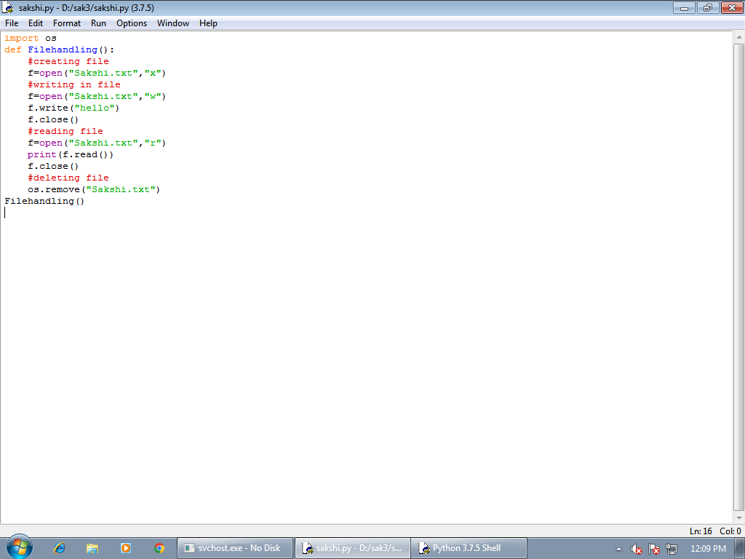

**OUTPUT:-**

